WEEK 1:
Exp 1. How to create project plan and product backlog for project and User story creation.
Creating project plan
- With project planning and project management running smoothly, IT departments are able to deliver more projects for the same budgets, and the majority of properly managed projects are completed by their due time/date.
- Planning for every project is very individual and specific. However, several major steps are going to be similar for many projects of the businesses.

Step #1: Write down project scope of work
- The first step to start with is to craft a scope statement and a general outline for the project. Creating the outline and the scope is usually the first step towards writing technical documentation and specs.
- Certainly, documentation is going to be changed in the scope of developing the project but initially, it is created by stakeholders and a project manager.
- The first step also contains developing the purpose and objectives of the project as well as the business justification for the project and is practically a basis for the entire future work.

Step #2:Organize deliverables into a work breakdown structure (WBS)
- When it comes to implementing project ideas effectively and promptly, there is a need to prepare deliverables.
- In turn, making deliverables is a part of the WBS that is the work breakdown structure for the project.
- A manager is the one to create the WBS according to the requirements of the customer, which need to include project scope, project tasks, and tasks split into simpler subtasks.
- Thus, the WBS is necessary as a project roadmap.

STEP #3: Get to know your dependencies
- When you already have the parts of your project to do with the WBS, it is time to create a to-do list for every subtask.
- At this point, many managers often ignore dependencies and this might create bottlenecks in the project.
- To avoid bottlenecks, there is a need to plan tasks, taking in mind their dependencies on other tasks and subtasks

STEP #4: Create a timeline
- Gantt chart is a very convenient tool to use when it comes to planning the milestones and the dependencies.
- With a Gantt chart, you can plan time and tasks in a way that at any given moment you can see the status your project is in.
- The example of a Gantt chart is represented in the picture below.
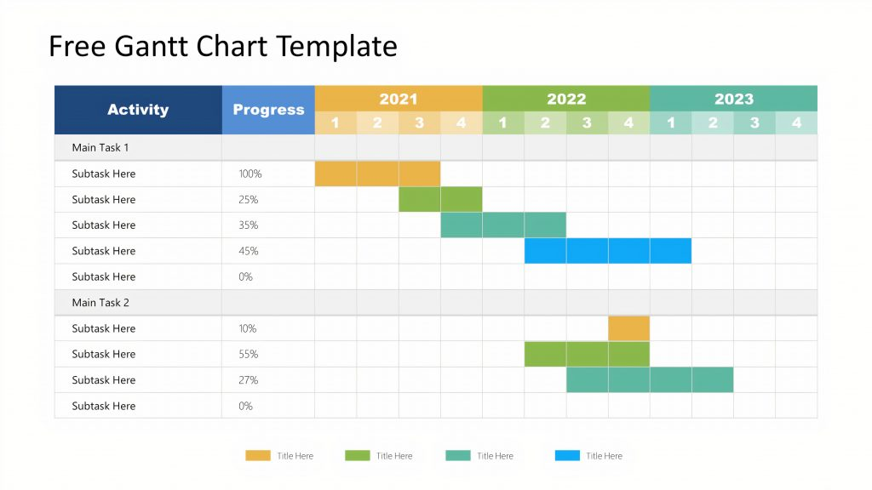

STEP #5 Plan budget
- It goes without saying, before starting the project, there is a need to estimate the total cost that you can afford.
- Ideally, there should be several estimations, depending on the timeline and features added to the project.
- For example, you might want to have the lowest and the highest total cost of your project at hand so you can estimate the project from several points of view.
- Potentially, this helps to be more realistic with the budget, and determine the features that are a must for the project and the ones that are auxiliary but desired.
- This kind of estimate might look like the following:
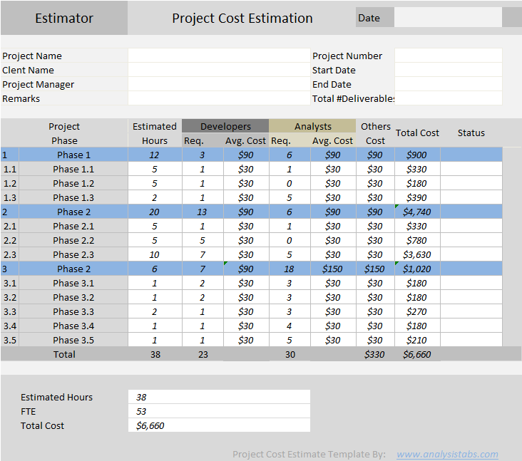
Creating product Backlog
According to the official Scrum Guide, the product backlog is “...an ordered list of everything that is known to be needed in the product.”
The product backlog sits outside of the sprint loop (meaning it contains work that will not be completed during the current sprint) but informs how your sprint will be planned. The product backlog is composed of feedback from:
- The development team
- Customer
- Stakeholders
Follow these steps to start your scrum product backlog.

1. Add ideas to the backlog
Stakeholders will typically be approaching you with ideas for product improvements

2. Get clarification
Once you’re approached by a stakeholder with a product addition or fix, make sure you understand:
- The reason behind the addition or fix
- The amount of value it contributes to the product as a whole
- The specifications of the item

3. Prioritize
The backlog should have clearly defined, high-priority items at the top and vague items that are not a priority at the bottom. If an item has no value, it should not be added to the backlog.

4. Update the backlog regularly
The backlog is a living document; make sure you’re constantly prioritizing, refining, and keeping the backlog up to date.
You may have hundreds of items in your backlog as ideas for product improvements are suggested. Some of these items may be discarded, but many of them will begin making their way up the backlog for further refinement and, ultimately, development.

Creating User Stories
A user story is a small unit of work in an Agile workflow. It is a short, written explanation of a particular user’s need and how it can be fulfilled.
User stories follow a simple template. The chosen user story format will outline the “who,” “what,” and “why” of a particular requirement.
- Who wants something?
- What do they want?
- Why do they want it?
The following template is one of the most common:
“As [persona], I want to [action], so that I can [benefit].”

Step 1: Outline acceptance criteria
It is the set of criteria that needs to be fulfilled for your user story to be considered complete. Define the specific acceptance criteria for each user story and use it as a checklist.

Step 2: Decide on user personas
Conduct extensive user research by creating surveys, hosting focus groups, and reading user forums. Analyze your data and search for patterns to identify your key personas.

Step 3: Create tasks
Break your user story down into numerous tasks to make it more manageable. If it is a complex requirement, you can also add subtasks. Include detailed descriptions, so your team is aligned on what each task requires.

Step 4: Map stories
Use story mapping to structure work in a large process. In this case, your user stories will take the form of ordered steps.

Step 5: Request feedback
Speak to users and potential customers to find out what they want. Ask them for their opinions on existing products or if they have suggestions for new features. Incorporate this feedback into your user story.

WEEK 2:
Exp 2.Create and manage product backlog using appropriate tool like Jira.
Summary: Customer registration functionality
Description
AS A customer
I WANT to have registration functionality
SO THAT I can successfully register.
Scope
- build a registration page
- customer validation
- customer should be able to change the phone number
- it should work in all the browser
- it should also work in mobile
Pre condition
- customer should have email and phone number
Acceptance criteria
Scenario1: customer can successfully resister
- “Given” I am on registration page
- “And” I give valid customer name and phone number
- “And” I click on sing in
- “Then” I will successfully resister
Scenario2: customer cannot successfully resister
- “Given” I am on registration page
- “And” I give invalid customer name and phone number
- “Then” I will get a error message as “registration failed incorrect customer name”

Summary: Customer checking availability
Description
AS A customer
I WANT to have checking available of hall
SOTHAT i can check the available halls
Scope
- build a available checking page
- it should be only inside the Karnataka
- customer should be able to check the available halls in their particular location
pre condition
- customer should have nearest halls in their location
Acceptance criteria
Scenario1:Customerscansuccessful check availability of hall in their location
- “Given “ I am on check available of hall page
- “And” I give particular location and date
Scenario2: customer can’t successfully check availability of hall in their location
- “Given “ I am on check available of hall page
- “And” I give wrong location
- “Then” I will get the error message as in valid location

Summary: Customer booking hall
Description

AS A customer
I WANT to booking hall
SO THATi can book the hall
Scope
- build a booking hall page
- customer should be able to change the date and location
Pre condition
- customer should be able to book the hall in their particular date
Acceptance criteria
Scenario 1: customer can successfully booking hall
- “Given” I am on booking page
- “And” I give available date time
- “And” I will book the hall
- “Then” I successfully booked the hall
Scenario 2: customer can’t successfully booking hall
- “Given” I am on booking page
- “And” I give invalid date and time
- “Then “I will get the error messages as their hall is already booked

Summary: Customer booking details
Description:
AS A customer
I WANT to block the hall
SO THAT I can get the booking details
Scope
- build abooking details page
- it should be able to see after the booking also
- customer should be able to change details if their want
Pre condition
- customer have to fill the every information given in the booking details
Acceptance criteria
Scenario 1: customer can successfully get the booking details
- “Given” I am on the booing details page
- “And” I fill the details
- “And” I have also blocked the hall
- “Then” I will successfully get the booing details
Scenario 2: customer will not get the booking details
- “Given” I am on the booking details page
- “And” I will fill the details without blocking hall
- “Then” I will get a error message as the hall is not blocked yet

Exp 3. Create Sprint 1 with required user stories.
1. Login to your Jira account and click on create project to create a new one.
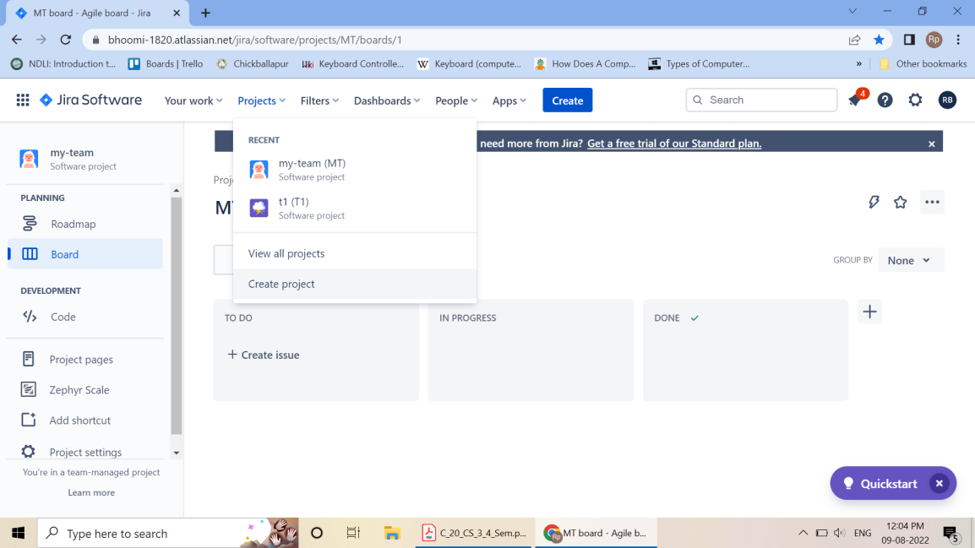
2.Choose your template.
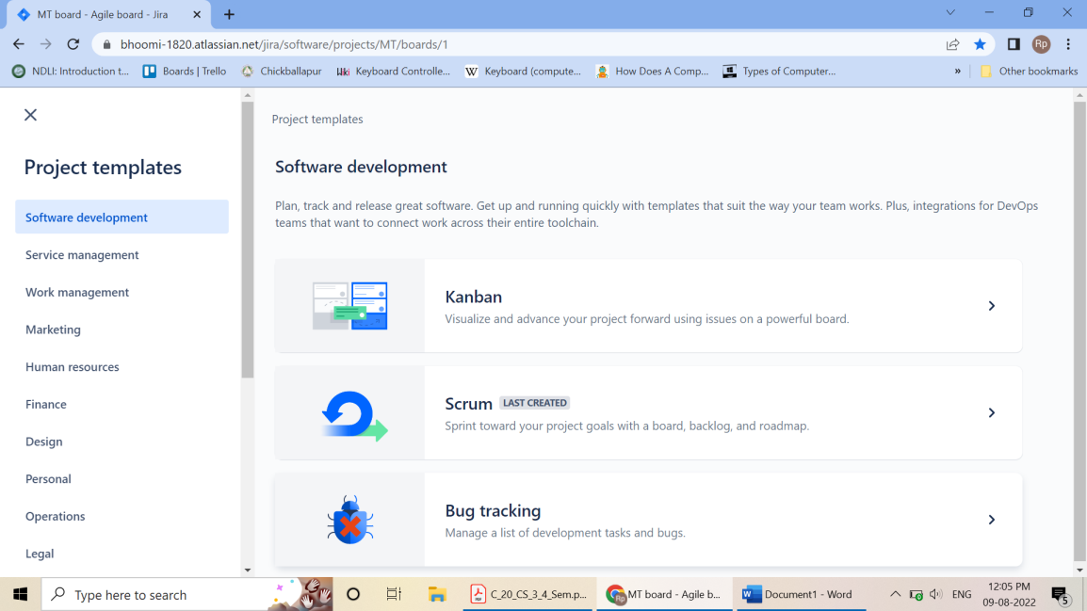

3.Give a name to your project.And then click on create project.
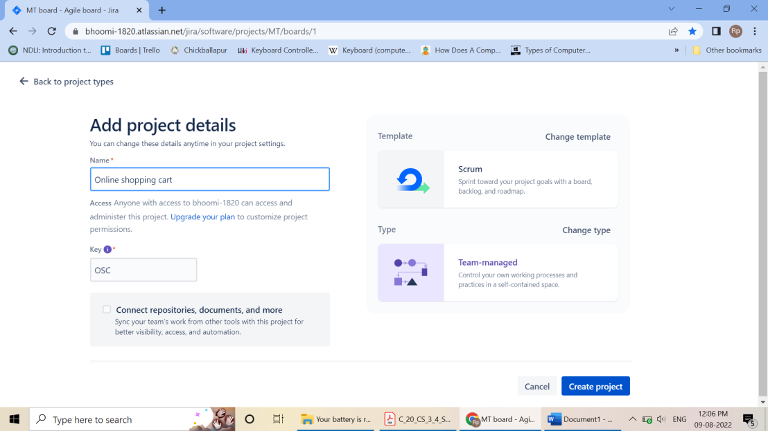
4.Now click on Create to create issue type of Story. And give the summary of your user story.
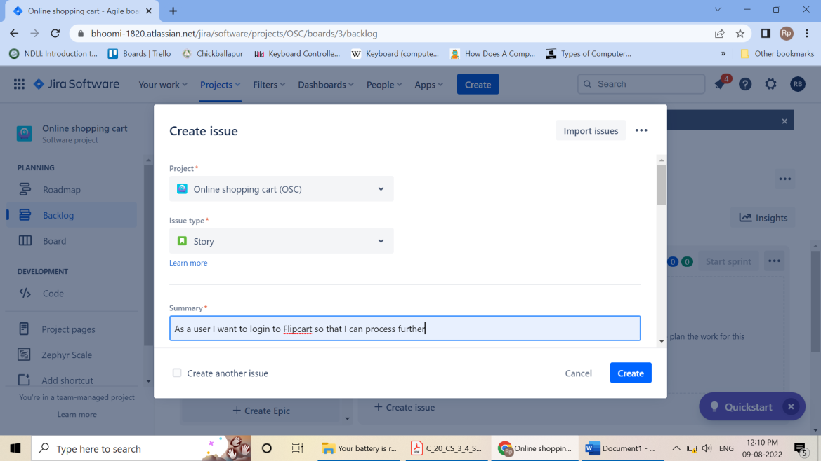
5.Create User Stories
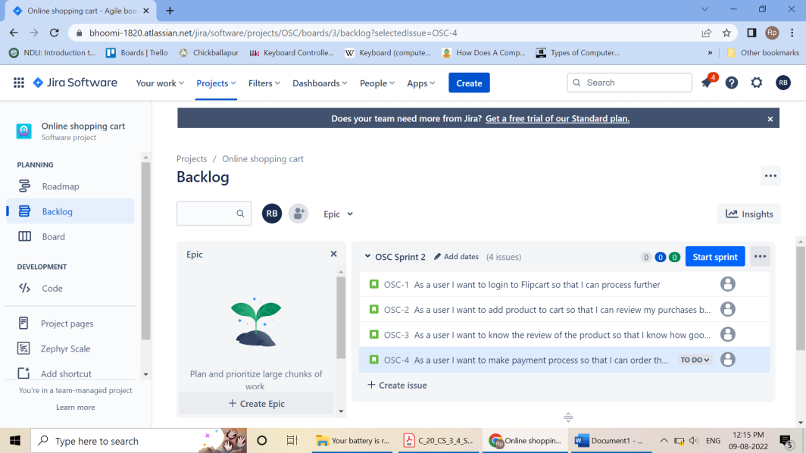
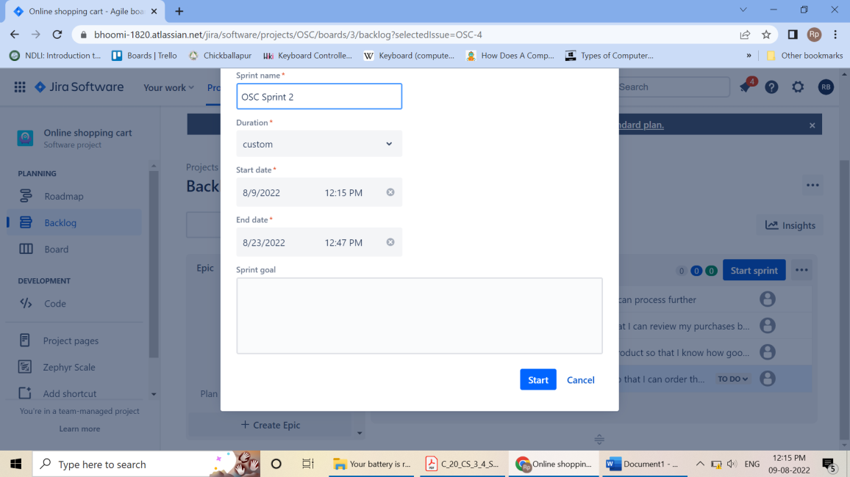
- Sprint1 is created on clicking on start
Note: Create user story for required topic and follow the steps below.
- Give a summary to your project.
- Now write a user story in Description box.
- Your story will then go into the backlog to be Assigned and auctioned by the project manager, product owner or other relevant stakeholders and click on start sprint
- Click on Board and select Insights
- Click on Insights and click “Sprint burn down”And click on Learn more.

Exp 4. Create UI/UX design - for created user stories (wire framing).
- Continue with your Gmail account or login to Figma.
- Firstcreate design file
- And adding elements to over design file from figma community
- Click on“ # ” button on the tool menu at the (Top left)
- Depends on which size you want to use choose the screen size from the right sidebar.
- Add background color to the frame by clicking it and add color from the “Fill” section in the (right panel).
- Create text button (click on “T” textbutton from the (Top left)
- Click on rectangle“⬜ ” button to select image from the popup menu at the (Top left)

WEEK 3:
Exp 5. Create repository–named mini project-1Push and pull operation in GitHub.
- Browse to the official Git website: https://git-scm.com/downloads
- Click the download link for Windows and allow the download to complete.
- Double-click the file to extract and launch the installer.
Git operations

Creating a repository
- Open browser, search for GitHub Login.
- Sign in with yourusername and password
- In the upper-right corner, use the drop-down menu, and select Newrepository.
- Give a name for your repository. For example, "hello-world".
- Add a description of your repository. For example, "Mini Project I"
- Click Create repository.
Push Operation:
- Go to add files and select upload files.
- Choose your files then select a file or folder click on open.
- Click on commit changes.
Clone or pull operation:
- Click on code dropdown button
- Click on Download Zip
Branching and merging
- git branch newbranch -to create a new branch
- git checkout newbranch -to checkout form master branch to newbranch
- Make the required changes to the file commit it and then merge
- git checkout newbranch
- gitmergenewbranch

Exp 6. Build a basic application on cloud
Create a web application
Use the program code (Forms – Use of HTML tags in forms select, input, file, etc.)
Deployment on cloud
- Open web browser and search for free cloud service (000webhost.com).
- Proceed sign in process through the Google account.
- Host free website and click on Manage Website.
- Towards left column, tools>>file manager and select upload files.
- Select public_html and upload the existing html file.
- After uploading, right click on the file and open.
- Make sure the file has been uploaded.
- Finally, we can perform the following operations
- View the output of the webpageapplication
- Download the webpage application
- Share the webpage application through the given below
  - Webhost_link + file_name.extension
- We can move from one directory to another
- Either we can copy the content of the file or by copying the whole file

WEEK 4:
Exp 8: Create a HTML Page using CSS

Step 1: Open VS Code and open a folder in VS Code.
Step 2: Create an index.html file. And write the following code.
//index.html
<!DOCTYPE html>
<html lang="en">
<head>
<meta charset="UTF-8">
<meta http-equiv="X-UA-Compatible" content="IE=edge">
<meta name="viewport" content="width=device-width, initial
scale=1.0">
<title>Index</title>
<style>
@import
url('https://fonts.googleapis.com/css2?family=Raleway&display=swap');
* {
font-family: 'Raleway', sans-serif;
margin: 0;
padding: 0;
box-sizing: border-box;
text-decoration: none;
}
nav {
border: 2px solid black;
padding: 1.2rem;
text-align: center;
background-color: black;
}
form {
margin-top: 1rem;
}
ul, li {
display: inline;
margin: 0 0.5rem;
}
a:hover {
color: yellowgreen;
}
.content{
text-align: center;
margin-bottom: 2rem;
}
h1 {
padding: 1rem 0;
}
.footer{
padding: 0 5rem;
}
.footer >p{
padding: 0.3rem 0;
}
</style>
</head>
<body>
<nav>
<div>
<ul>
<a href="#">
<li>Home</li>|
</a>
<a href="#">
<li>About</li>|
</a>
<a href="#">
<li>Blog</li>|
</a>
<a href="#">
<li>Contact</li>
</a>
</ul>
</div>

</nav>
<div class="content">
<h1>Vikas Singh</h1>
<p>Loremipsum dolor sit, ametconsecteturadipisicingelit.
Provident optiopariatur, at quasi, corruptivel
esse in aliquamexercitationemautexpeditaaspernatur
qui? Isteobcaecatimodi, inciduntconsectetur
architectomaxime.
</p>
<form action="">
<label for="">Email: </label><input type="text">
<button>Subscribe</button>
</form>
</div>
<div class="footer">
<hr>
<p>This page is created by XanderBilla</p>
</div>
</body>
</html>
Step 3: Click on Go Live present at the task bar of the VS Code in corner.
Output

Exp 9.Create a form like registration form or feedback form, after submit hide create form and enable the display section using java script.

Registration.html
<html>
<head>
<title> Registration Form</title>
<script>
Functionpassvalues()
{
var name = document.getElementById("name").value;
var email = document.getElementById("email").value;
var address = document.getElementById("address").value;
localStorage.setItem("name",name);
localStorage.setItem("email",email);
localStorage.setItem("address",address);
return;
}
</script>
</head>
<body>
<h1>Registrtion Form</h1>
<form action="Details.html">
<fieldset>
<legend>Registration</legend>
<label> Name </label>
<input type="text" id="name"/><br><br>
<label> Email ID </label>
<input type="email" id="email"/><br><br>

<label> Address </label>
<input type="address" id="address"/><br><br>
<input type="submit" value="submit" onclick="passvalues()"/>
</fieldset>
</form>
</body>
</html>

Details.html
<html>
<head>
<title> Details</title>
</head>
<body>
<form>
Your Name is:<p id="name"></p><br>
Your email is:<p id="email"></p><br>
Your address is:<p id="address"></p>
<script>
document.getElementById("name").innerHTML = localStorage.getItem("name");
document.getElementById("email").innerHTML = localStorage.getItem("email");
document.getElementById("address").innerHTML = localStorage.getItem("address");
</script>
</form>
</body>
</html>

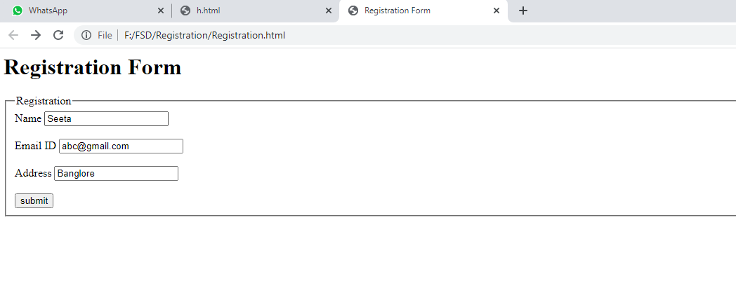
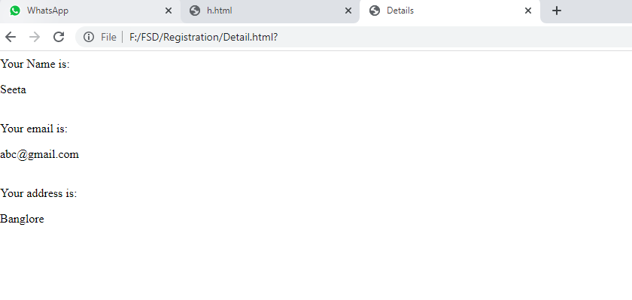

Exp 10.Create and run simple program in TypeScript Install TypeScript using Node.js Package Manager (npm).

Step-1 Install Node.js. It is used to setup TypeScript on our local computer.
To install Node.js on Windows, go to the following link: https://www.javatpoint.com/install-nodejs

Step-2 Install TypeScript. To install TypeScript, enter the following command in the Terminal Window.
- npm install typescript --save-dev //As dev dependency
- npm install typescript -g //Install as a global module
or
- npm install -g typescript
- npm install typescript@latest -g //Install latest if you have an older version

Step-3 To verify the installation was successful, enter the command $ tsc -v in the Terminal Window.
Install Live server
npm install -g live-server

Create and run first program in TypeScript
- open command prompt
- go to d: drive(any drive)
- d:\>mkdir typescript
- d:\>cd typescript
- d:\typescript>npm install typescript --save-dev
- open visual studio code
- file-open folder-choose typescript folder from d:
- create new file- save it as types.ts(any name.ts)
- Write the below code and save it
- console.log("Hello World");
- go to command prompt and compile the program
- tsctypes.ts or tsc.cmd types.ts
- run the program
- node types.js
- Observe the output
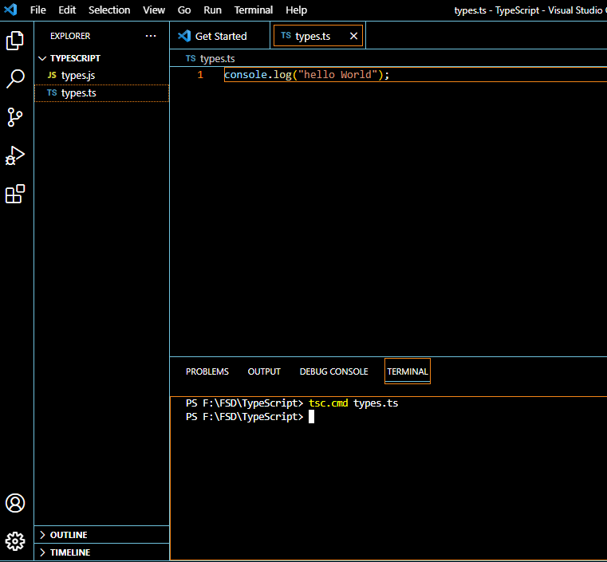
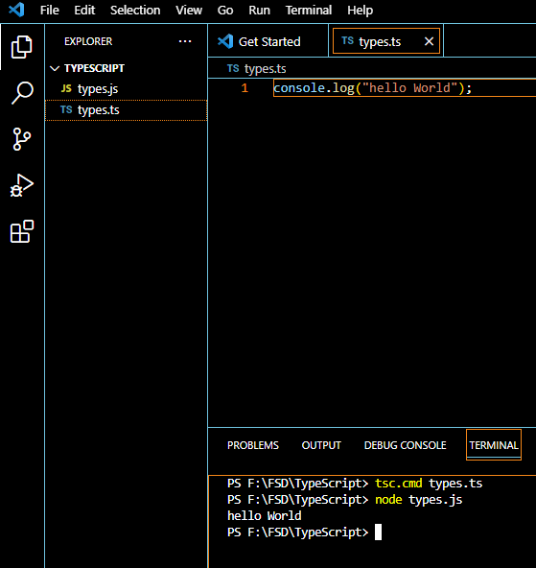

WEEK 5:
Exp 11.Demonstrate use of React Props.

App.js
import React from 'react';
importClassprops from "./Classprops";
importFunctionprops from "./Functionprops";

class App extends React.Component{
render() {
return (
<div>
<Classprops name="Learner1" place="Bagepalii"></Classprops>
<p>Child Component</p>
<Classprops name="Learner2" place="Banglore"></Classprops>
<button>Click</button>
<Classprops name="Learner3" place="Mysore"></Classprops>
<Functionprops name="Learner4" place="Madikeri"/>

</div>
);
}
}
export default App;

Functionprops.js
import React from "react";
functionFunctionprops(props) {
return (
<div>
<h3>This is functional component</h3>
<h3>
Hello {props.name} from {props.place} Welcome to reactjs props
</h3>
</div>
);
}
export default Functionprops;

Classprops.js
import React, { Component } from 'react';
classClassprops extends Component {
render() {
return (
<div>
<h1>Hello {this.props.name} from {this.props.place} Welcome to react props</h1>
<p>{this.props.children}</p>
</div>
);
}
}
export default Classprops;

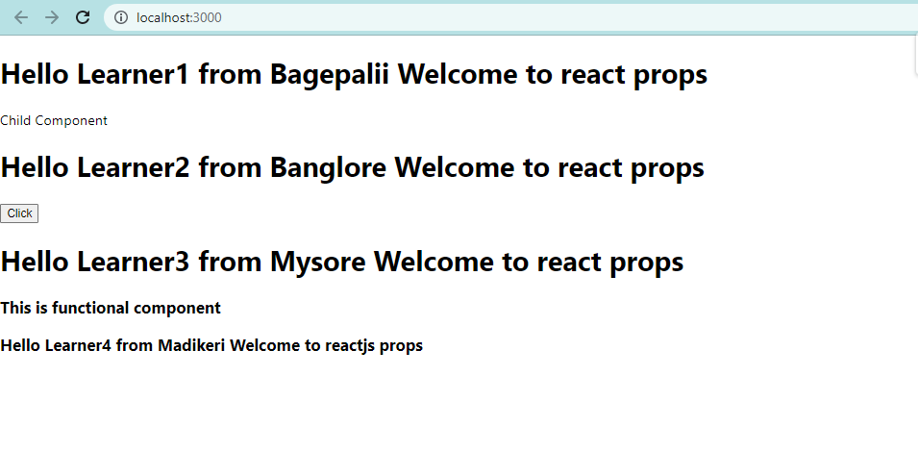

Exp 12. Using List and keys in React .

//App.js
App(){
const Student = [
{
id: 1,
name: "Vikas Singh",
age: 24
},
{
id: 2,
name: "AnchalRai",
age: 23
}
]
return (
data.map(i, item =>
<Student key={i} stName={item.name} stAge={items.age}>
)
}
//Student.js
import React, { Fragment } from 'react';
App(props){
return (
<Fragment>
<h1>Student Info</h1>
<h4>Name: {props.stName} | Age: {stAge}</h4>
</Fragment>
)
}

Exp 13 .Forms - Use of HTML tags in forms like select, input, file, textarea, etc.
<html>
<head>
<title>Form Elements</title>
</head>
<body>
<form>
<lable>Text Box</lable>
<input type="text" id="t1" name="name" value=""/><br><br>

Radio Button: <br>
<input type="radio" id="r1" name="" value=""/>Male<br> <br>
<input type="radio" id="r1" name="" value=""/>FeMale<br><br>
Check Box:<input type="checkbox" id="c1" name="" value=""/><br><br>
File:<input type="file" id="e1" name="file" value=""/><br><br>

Select:<br>
<label>Sem</label>
<select name="sem" id="sem">
<option value="1">1 Sem</option>
<option value="2">2 Sem</option>
</select><br><br>

Text Area:<br>
<textarea id="ta1" name="textarea" rows="4" cols="50">
At w3schools.com you will learn how to make a website.
</textarea><br><br>
<fieldset>
<legend>Personal Details:</legend>
<label>First name:</label>
<input type="text" id="fname" name="fname"><br><br>
<label>Last name:</label>
<input type="text" id="lname" name="lname"><br><br>
</fieldset><br><br>
Button:<input type="button" id="t1" name="" value="Submit"/><br>
</form>
</body>
</html>

Output:-
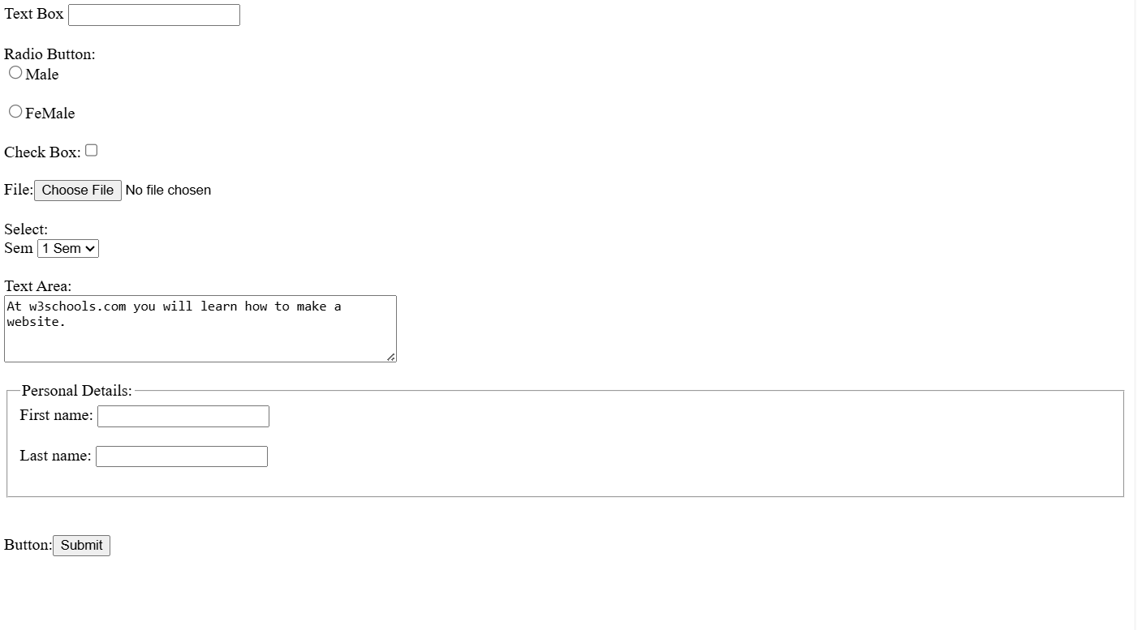

Exp 14.Testingsinglepageapplication (Registration form) using React.

CreatingReact.jsapp
Step1:-Install the npm using Command
“npminsatall”
Step2:-Create app using below command
“npx create-react-app projectName”
Step3:- After completed the installation go to the directory
"cdprojectName”
Step4:-Create Hello.js file in src folder

Testingsinglepageapplication

Hello.js

import { useState } from 'react';
import './App.css';
export default function Form()
{
// States for registration
const [name, setName] = useState('');
const [email, setEmail] = useState('');
const [password, setPassword] = useState('');
const [submitted, setSubmitted] = useState(false);

consthandleName = (e) => {
setName(e.target.value);
};

consthandleEmail = (e) => {
setEmail(e.target.value);
};

consthandlePassword = (e) => {
setPassword(e.target.value);
};

consthandleSubmit = (e) => {
e.preventDefault();
if (name === '' || email === '' || password === '') {
alert("Please enter all the fields");
} else {
setSubmitted(true);
}
};
// Showing success message
constsuccessMessage = () => {
if(submitted)
return (
<div className="success" >
<h1>User {name} successfully registered!!</h1>
</div>
);
};
return (
<div className="form">
<div>
<h1> Login to GPT Bagepalli Website </h1>
</div>
{/* Calling to the methods */}
<div className="messages">
{successMessage()}
</div>

<form>
<fieldset>
{/* Labels and inputs for form data */}
<label className="label">Name</label>
<input onChange={handleName} className="input" value={name} type="text" /><br></br>
<label className="label">Email</label>
<input onChange={handleEmail} className="input" value={email} type="email" /><br></br>
<label className="label">Password</label>
<input onChange={handlePassword} className="input" value={password} type="password" /><br></br>
<button onClick={handleSubmit} className="btn" type="submit">
Submit
</button>
</fieldset>
</form>
</div>
);
}

App.css
.input {
width: 30%;
padding: 12px 20px;
margin: 8px 0;
display: inline-block;
border: 1px solid #ccc;
border-radius: 4px;
box-sizing: border-box;
}
Index.js
import Home from './Home';
<Home/>
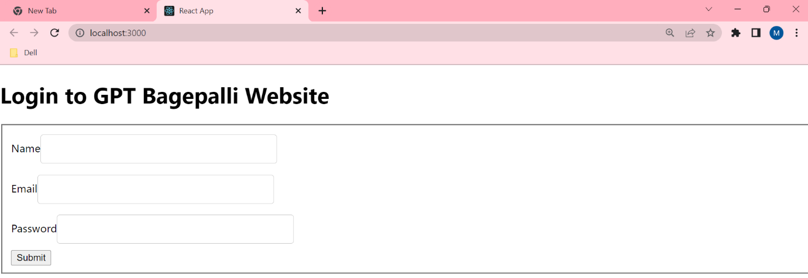

Exp 16. Implement navigation using react router

Add React Router
- To add React Router in your application, run this in the terminal from the root directory of the application:
npmi -D react-router-dom

Index.js
importReactDOM from "react-dom/client";
import { BrowserRouter, Routes, Route } from "react-router-dom";
import Layout from "./pages/Layout";
import Home from "./pages/Home";
import Blogs from "./pages/Blogs";
import Contact from "./pages/Contact";
importNoPage from "./pages/NoPage";
export default function App() {
return (
<BrowserRouter>
<Routes>
<Route path="/" element={<Layout />}>
<Route index element={<Home />} />
<Route path="blogs" element={<Blogs />} />
<Route path="contact" element={<Contact />} />
<Route path="*" element={<NoPage />} />
</Route>
</Routes>
</BrowserRouter>
);
}
const root = ReactDOM.createRoot(document.getElementById('root'));
root.render(<App />);
Create a folder name called pages. Within a pages create following files.
Blogs.js
const Blogs = () => {
return<h1>Blog Articles</h1>;
};
export default Blogs;
Contact.js
const Contact = () => {
return<h1>Contact Me</h1>;
};
export default Contact;

Home.js
const Home = () => {
return<h1>Home</h1>;
};
export default Home;

Layout.js
import { Outlet, Link } from "react-router-dom";
const Layout = () => {
return (
<>
<nav>
<ul>
<li>
<Link to="/">Home</Link>
</li>
<li>
<Link to="/blogs">Blogs</Link>
</li>
<li>
<Link to="/contact">Contact</Link>
</li>
</ul>
</nav>
<Outlet />
</>
)
};export default Layout;
NoPage.js

constNoPage = () => {
return<h1>404</h1>;
};
export default NoPage;

App.css
ul {
list-style-type: none;
margin: 0;
padding: 0;
overflow: hidden;
background-color: #04AA6D;
}

li {
float: left;
border-right:1px solid #bbb;
}
li a {
display: block;
color: white;
text-align: center;
padding: 14px 16px;
text-decoration: none;
}

li a:hover:not(.active) {
background-color: #111;
}

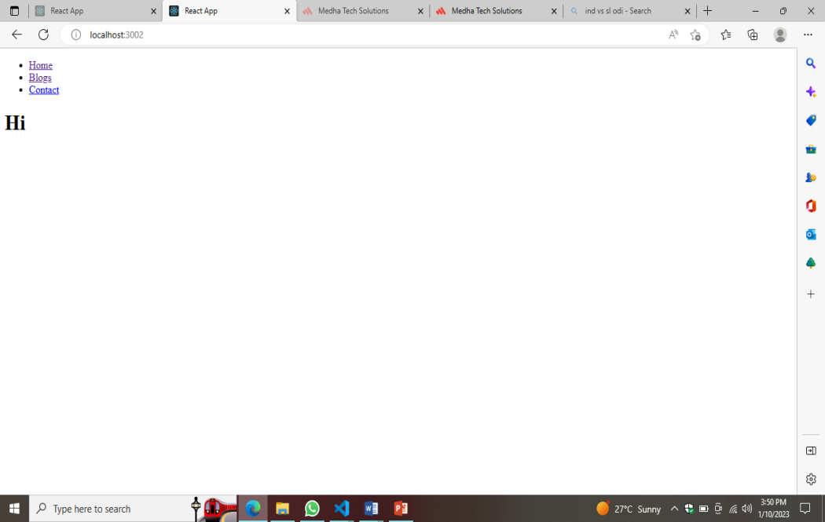

Exp 17. Build single page application (Add Product to Product List)
App.js
import Header from "./Header";
import './App.css'
import Products from "./Product";
import { useState } from "react";
importCartList from "./CartList";
function App() {
const [product, setproduct] = useState([
{
url:'https://th.bing.com/th/id/OIP.KJ863TFexg2ux2Lm6VxfdgHaHa?w=209&h=209&c=7&r=0&o=5&dp
=1.3&pid=1.7',
name: 'lenovoideapad Slim 3',
category: 'Laptop',
seller: 'Lenovo',
price: 57000
},
{
url:'https://tse1.mm.bing.net/th?id=OIP.Wd5h_lUDFjl4tTtuIR_HjwHaHa&pid=Api&P=0&w=300&h=300',
name: 'fastrack w98',
category: 'Watch',
seller: 'Fastrack',
price: 1599
},
{
url: 'https://i.ytimg.com/vi/KRxNI--IxrY/maxresdefault.jpg',
name: 'mi 12pro',
category: 'Mobile',
seller: 'Mi',
price: 20000
},
{
url: 'https://cdn1.smartprix.com/rx-iN1Shi5s0-w1200-h1200/boat-rockerz-450-pro.jpg',
name: 'boAt v20',
category: 'Headset',
seller: 'boAt',
price: 999
},
{
url: 'https://rukminim1.flixcart.com/image/1408/1408/washing-machine/z/c/d/ifb-digital8-kg-direct-drive-digital-8-kg-direct-drive-original-imad2zcwczwuzge4.jpeg?q=90',
name: 'IFB Washing Machine',
category: 'Electronics',
seller: 'Electro',
price: 2000
},
])
const [cart, setCart] = useState([])
const [showCart, setShowCart] = useState(false)
constaddToCart = (data) => {
setCart([...cart, { ...data, quantity: 1 }])

}
consthandleShow = (value) => {
setShowCart(value)
}
return (
<div>
<Header count={cart.length} handleShow={handleShow} />
{
showCart ?
<CartList cart={cart} /> :
<Products product={product} addToCart={addToCart} />
}
</div>
)
}
export default App;
header.js
import React from 'react'
import './App.css'
function Header(props) {
return (
<div className='flex shopping-cart'>
<div onClick={()=>props.handleShow(false)}>ShoppingCart</div>
<div onClick={()=>props.handleShow(true)}> Cart
<sup>{props.count}</sup>
</div>
</div>
)
}
export default Header;
Product.js
import React from 'react'
function Products({product,addToCart} ){
return (
<div className='flex'>{
product.map((productitem,productIndex)=>{
return(
<div style={{ width:'50%'}} >
<div className='product-item'>
<imgsrc={productitem.url}width="40%"/>
<p>{productitem.name} | { productitem.category}</p>
<p>{productitem.seller}</p>
<p>Rs.{productitem.price}</p>
<button onClick={()=>addToCart(productitem)}>Add Cart</button>
</div>
</div>
)
})
}
</div>
)
}
export default Products;
CartList.js
import React,{useState,useEffect} from 'react'
import'./App.css'
functionCartList({cart}) {
const [CART,setCART]= useState([])
useEffect(() => {
setCART(cart)
}, [cart])
return (
<div>
{
CART?.map((cartitem,cartindex)=>{
return(
<div>
<imgsrc={cartitem.url}width={60}/>
<span> {cartitem.name} </span>
<button onClick={()=>{
const _CART= CART.map((item,index)=>{
returncartindex ===index? {...item,quantity:item.quantity>0?item.quantity1:0}:item
})
setCART(_CART)
}}>
- </button>
<span> {cartitem.quantity} </span>
<button onClick={()=>{
const _CART= CART.map((item,index)=>{
returncartindex ===index? {...item,quantity:item.quantity+1}:item
})
setCART(_CART)
}}>+ </button>
<span>Rs.{cartitem.price* cartitem.quantity} </span>
</div>
)
})
}
<p>Total=<span>
</span>
{CART.map(item=>item.price*item.quantity).reduce((total,value)=>total+value,0)}
</p>
</div>
)
}
export default CartList;
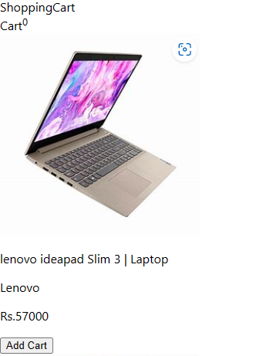
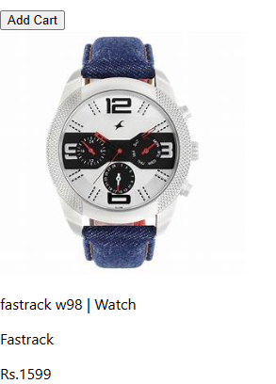
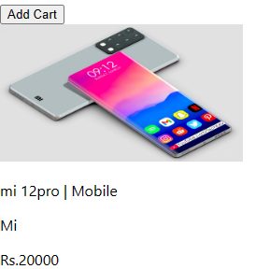

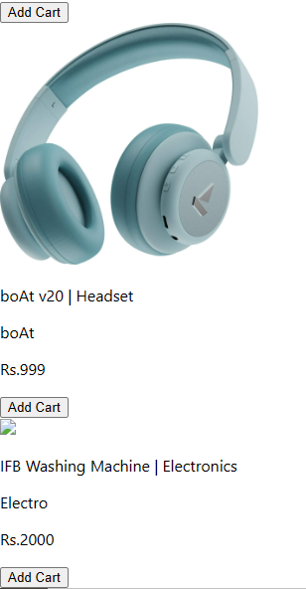

Exp 18. Setting up environment for creating JAVA Application - Install JAVA, JAVA Editor (such as IntelliJ, Eclipse etc.), Install DBMS
(MySQL, PostgreSQL or any other).

Install JDK JAVA
Step 1: Go to Java official website and go to downloads search for Java 17
Step 2: Download the MSI installer.
Step 3: Open the downloads folder and execute the downloaded JDK executable file.
Step 4: Select the installation directory and click on Install, once the JDK install click on
close.
Download MySQL
The simplest and recommended method is to download MySQL Installer for Windows
from https://dev.mysql.com/downloads/installer/ and execute it.

Select mysql-installer-web-community-8.0.23.msi if you have good internet connection,
otherwise choose mysql-installer-community-8.0.23.msi.
Install MySQL
After downloading, unzip it, and double click the MSI installer .exe file.
Then follow the steps below:
Step 1: "Choosing a Setup Type" screen: Choose "Full" setup type. This installs all
MySQL products and features. Then click the "Next" button to continue.
Step 2: "Check Requirements" screen: The installer checks if your pc has the
requirements needed. If there is some failing requirements, click on each item to try to
resolve them by clicking on the Execute button that will install all requirements
automatically. Click "Next".
Step 3: "Installation" screen: See what products that will be installed. Click "Execute" to
download and install the Products. After finishing the installation, click "Next".
Step 4: "Product Configuration" screen: See what products that will be configured.
Click the "MySQL Server 8.0.23" option to configure the MySQL Server. Click the "Next"
button. Choose the "Standalone MySQL Server/Classic MySQL Replication" option and
click on the "Next" button. In page "Type and Networking" set Config Type to
"Development Computer" and "Connectivity" to "TCP/IP" and "Port" to "3006". Then,
click the "Next" button.
Step 5: "Authentication Method" screen: Choose "Use Strong Password Encryption for
Authentication". Click "Next".
Step 6: "Accounts and Roles" screen: Set a password for the root account. Click "Next".
Step 7: "Windows Service" screen: Here, you configure the Windows Service to start
the server. Keep the default setup, then click "Next".
Step 8: "Apply Configuration" screen: Click the "Execute" button to apply the Server
configuration. After finishing, click the "Finish" button.
Step 9: "Product Configuration" screen: See that the Product Configuration is
completed. Keep the default setting and click on the "Next" and "Finish" button to
complete the MySQL package installation.
Step 10: In the next screen, you can choose to configure the Router. Click on "Next",
"Finish" and then click the "Next" button.
Step 11: "Connect To Server" screen: Type in the root password (from step 6). Click the
"Check" button to check if the connection is successful or not. Click on the "Next"
button.
Step 12: "Apply Configuration" screen: Select the options and click the "Execute"
button. After finishing, click the "Finish" button.
Step 13: "Installation Complete" screen: The installation is complete. Click the "Finish"
button.
Install Eclipse
Step 1: Go to eclipse.org and download the exe file for windows
Step 2: Open the downloads folder and execute the downloaded eclipse executable file.
Step 3: Select the installation directory and click on Install, once the eclipse install click
on Launch.
WEEK 9:
Exp 21. CRUD Operations on document using Mongo DB.

Creating a Table.
db.createCollection("student")
{ ok: 1 }
show tables
student

insert() Method
To insert data into MongoDB collection, you need to use MongoDB's insert() or save() method.

Syntax: db.COLLECTION_NAME.insert(document)

db.student.insert({"id":1,"name":"chandru","mark":300})

db.student.insertMany([{"id":1,"name":"chandru","mark":300},{"id":2,"name":"suman","mark":290}])

View data from Table.
db.student.find({})

Update.
db.student.update({"name":"chandru"},{$set:{"name":"sekar",id:5}})

Delete only one data.
db.student.deleteOne({"name":"sekar"})

WEEK 11:
Exp 23: Create a docker image and run a container using docker image. Also do the same using docker file.

Step 1: Go to play with docker official website
Step 2: Click on Login
Step 3: Click on start
Step 4: Click on create new instance at left side of the page
Step 5: To create a docker image run the following command –
docker create <IMAGE NAME>
Step 6: Show the existing images of docker use the command –
docker images
Step 7: To run a docker image in a container execute the following command –
docker run -it <IMAGE>
Step 8: Exit the container you're in.
Step 9: Click on Editor to create a dockerfile
Step 10: Enter the following script and save the file
FROM ubuntu
MAINTAINER vikas
RUN apt-get update
CMD ["echo", "Hello World"]
Step 11: Now rename the file to `Dockerfile`

mv<filename>Dockerfile
Step 12: To create an image and run container using the docker file hit the following
command
docker build .
Step 13: If you want to deploy a web application create a NGINX container To do so
follow the steps below
Create a NGINX image with -
Step 13.a: Run the NGINX container by binding the port number using -p flag
docker run -p 8085:80 nginx
Step 13.b: Now click on open port on top of screen and enter the port number you
banded
Step 13.c: The deployed application will be opened in a new tab

